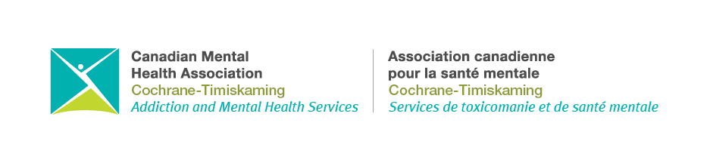
October 30, 2023
CMHA-CT Achieves Accreditation with Exemplary Standing though Accreditation Canada

Accreditation Canada is a global, not-for-profit organization that has been established for over 60 years and is affiliated with the Health Standards Organization (HSO). The agency works alongside federally recognized health and social service organizations looking to achieve the highest standards of care for their community members.

In June 2023, the Canadian Mental Health Association – Cochrane Timiskaming branch (CMHA-CT) achieved the honour of being Accredited with Exemplary Standing under Accreditation Canada’s Qmentum Global™ accreditation program.

This level of accreditation is based on rigorous assessments by Accreditation Canada analyzing all services and programs, policies, procedures, and is also based on feedback from interviews with clients, volunteers, staff, and agency stakeholders.

CMHA-CT’s accreditation status represents the quality, people-centered care being provided to the Cochrane-Temiskaming region in ensuring overall well-being for our communities. These objectives have been met through the wide range of non-profit services (over 13 offered across 5 locations) encompassing mental health and addictions recovery-focused programs accessible to clients of all ages and their families.

Upholding Accreditation with Exemplary Standing requires continued care competency that CMHA-CT is committed to maintaining and developing ongoingly.

